NATIONAL UNIVERSITY OF COMPUTER AND EMERGING SCIENCES

[KARACHI CAMPUS]

FAST School of Computing **Spring 2025**

**DLD Project Report**

**SMART ATTENDANCE SYSTEM**

**Date of submission:**

**Group Members:** 28 April,2025

Meharwan Kataria (24k-0864) **Submitted to:**

Sanjna Kataria (24k-0738) Ramsha Iqbal

## **1. Introduction**

Manual attendance systems are often inefficient, prone to errors, and time-consuming. To address these challenges, this project proposes a **Smart Attendance System** that leverages **RFID technology** for identification and **Bluetooth communication (HC-05)** for real-time, wireless data transmission to mobile devices. This system aims to be cost-effective, reliable, and easy to implement.

## **2. Objective**

The main objectives of this project are:

* To design a **contactless attendance system** using RFID and Bluetooth.
* To **transmit attendance data wirelessly** to a mobile device.
* To **minimize errors** caused by manual attendance taking.
* To enable **real-time recording** of attendance with possibilities for future integration into broader systems like HR, academic records, or event management platforms.

## **3. System Overview**

The Smart Attendance System functions by using an **RFID reader (RC522)** to scan individual **RFID cards/tags**. Each card contains a **Unique Identifier (UID)**. The **Arduino Uno** reads this UID and sends it over **Bluetooth (HC-05 module)** to a paired mobile device. The mobile device then logs or processes the received UID data.

### Key Features:

* Contactless scanning.
* Wireless transmission to mobile.
* Real-time attendance logging.
* Portable and energy-efficient design.

## **4. Components Used**

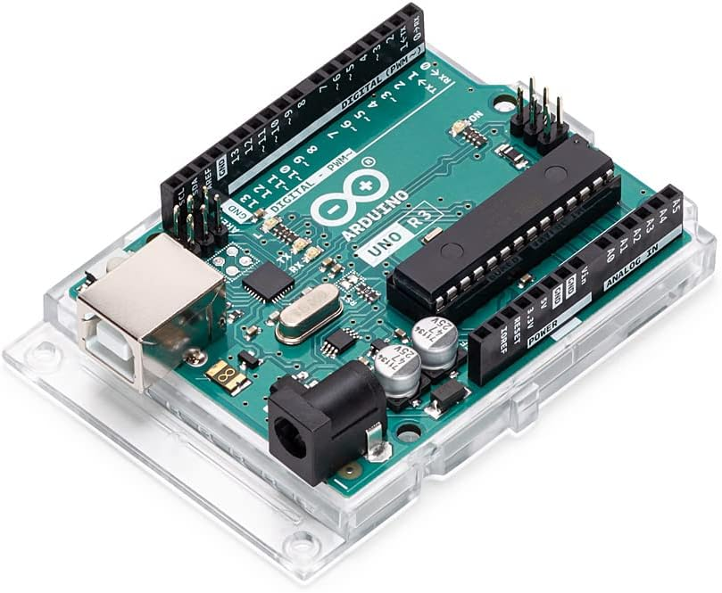

### **4.1 Arduino Uno**

* Serves as the **central controller** of the system.
* Reads data from the RFID reader.
* Sends the UID to the HC-05 Bluetooth module using UART communication.

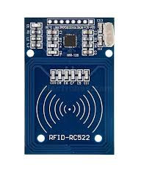

### **4.2 RFID Module (RC522)**

* Reads RFID cards/tags.
* Communicates with Arduino via **SPI (Serial Peripheral Interface)**.
* Each card/tag has a **unique UID** that identifies a user.

### **4.3 RFID Tags/Cards**

* Carry a **pre-programmed UID**.
* Represent individual users (students, employees, participants, etc.).

### **4.4 HC-05 Bluetooth Module**

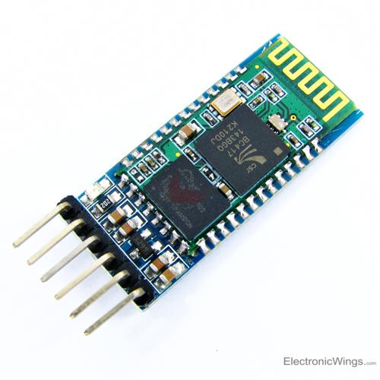

* Transmits UID data to a **paired mobile device** wirelessly.
* Operates on **UART** (serial communication with Arduino).

### **4.5 Mobile Device (Android/iOS)**

* Receives and logs/display UID data.

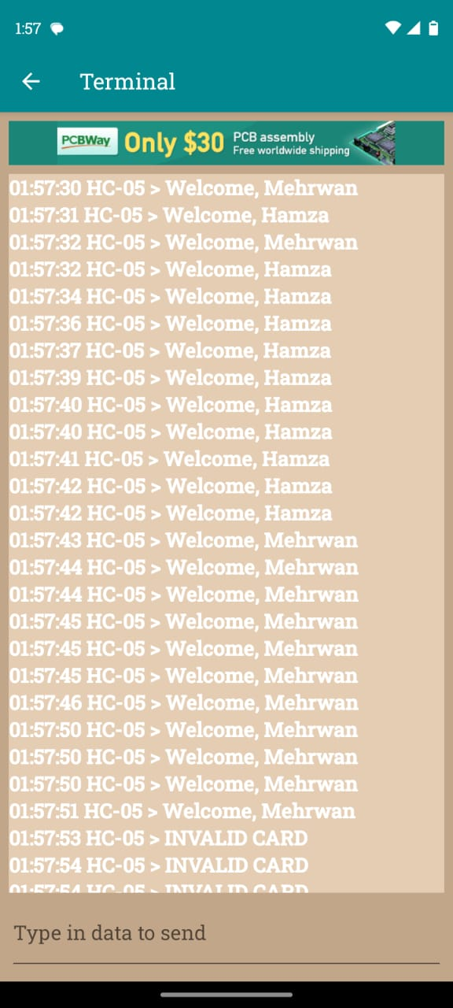

* Can use a **Bluetooth terminal app** or a **custom-developed app** for attendance management.

### **4.6 Power Supply**

* System can be powered via **USB connection** or a **portable battery pack** for mobility.

## **5. System Connectivity and Data Flow**

### **5.1 System Diagram:**

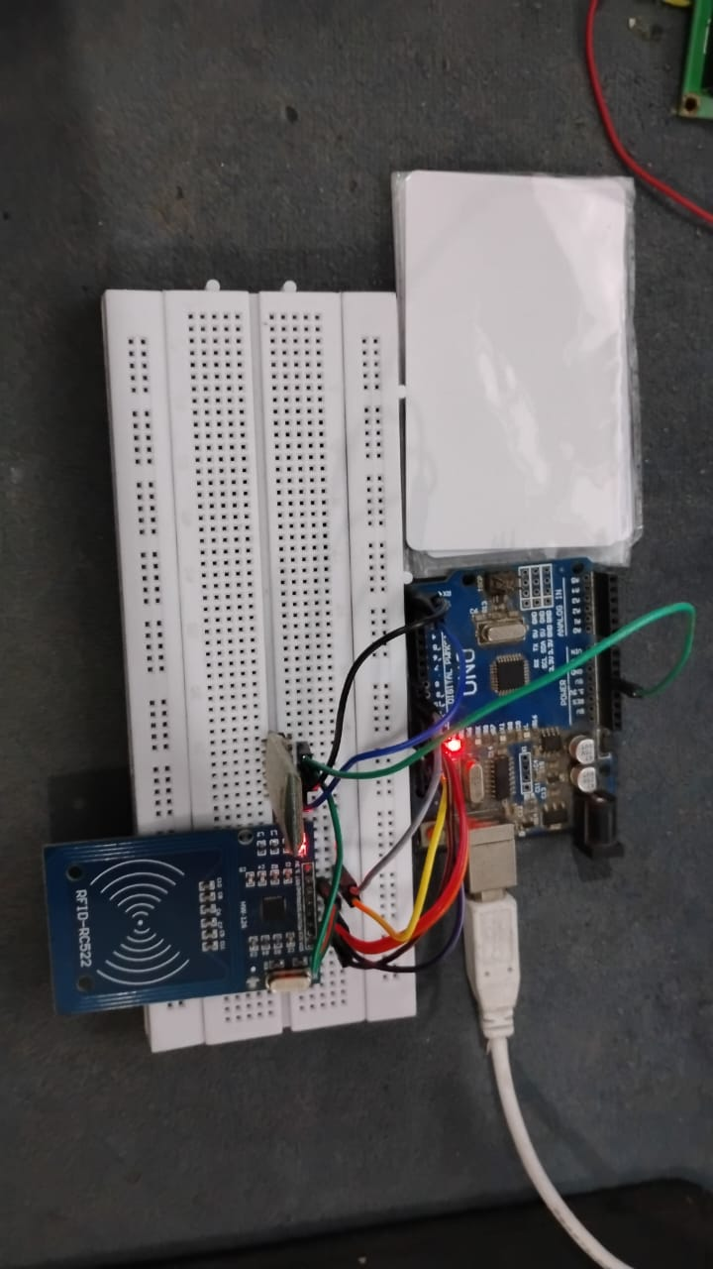

### **5.2 Step-by-Step Working**

1. **User taps** the RFID card/tag on the RC522 reader.
2. **RC522 module** reads the UID of the card.
3. **Arduino** processes the UID and sends it through serial communication to the HC-05 Bluetooth module.
4. **HC-05 module** transmits the UID wirelessly.
5. **Mobile device** receives the UID and logs/displays the attendance information.

## **6. UID Usage**

* Each RFID card has a **hardcoded UID** (example: 73 22 4A B3).
* The system can either:
  + Compare the UID against a **predefined database** in Arduino, or
  + **Send the UID directly** to the mobile device for processing.
* UID ensures **unique identification** for each individual, preventing errors like proxy attendance.

## **7. Arduino Source Code**

Below is the core Arduino code used to interface the RFID module with the Arduino Uno and identify users based on **hardcoded UIDs**: 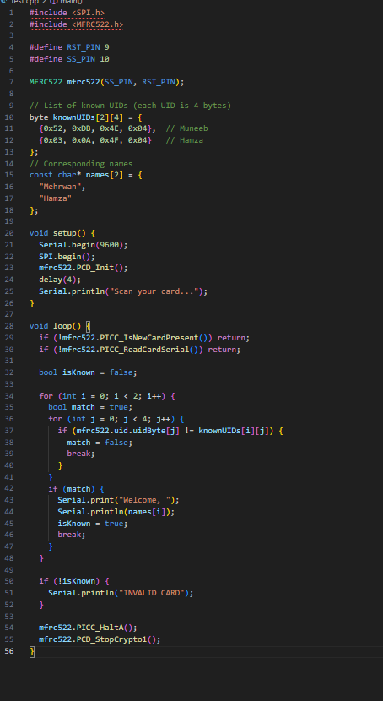

This code can be compiled using arduino ide.

### **Code Explanation**

* **Libraries Used**: SPI.h for SPI communication and MFRC522.h for RFID functionality.
* **UID Matching**: The code compares the scanned UID with a list of predefined UIDs stored in a 2D array.
* **User Identification**: If a match is found, a welcome message with the corresponding name is printed to the Serial Monitor.
* **Fallback Message**: If no match is found, it prints "INVALID CARD".

### **Significance**

* This method allows for a **simple and quick identification** of users.
* It is ideal for **small-scale implementations** where only a limited number of RFID cards are used.
* For larger deployments, future versions of the system could fetch UIDs dynamically from **external storage** or a **cloud database**.

## **8. Advantages of the Project**

* **Contactless** and hygienic attendance system.
* **Wireless transmission** reduces wiring complexity.
* **Portable** and easy to deploy.
* **Cost-effective** compared to commercial biometric solutions.
* **Minimizes human errors** and eliminates need for paper records.
* **Scalable** for future integration with cloud services, notifications, and backend databases.

## **9. Future Enhancements**

* **Add a Real-Time Clock (RTC)** module to log time and date with each UID.
* **Store data locally** on a **microSD card** or sync with a **cloud database**.
* Develop a **dedicated mobile app** for better user experience and attendance reporting.
* **Display student/employee name and entry time** on an **LCD** or **OLED** screen after scan.
* Add **LED indicators** or **buzzers** for feedback on successful scans.
* Enable **automatic notifications** (e.g., SMS/email alerts) for absences or late entries.